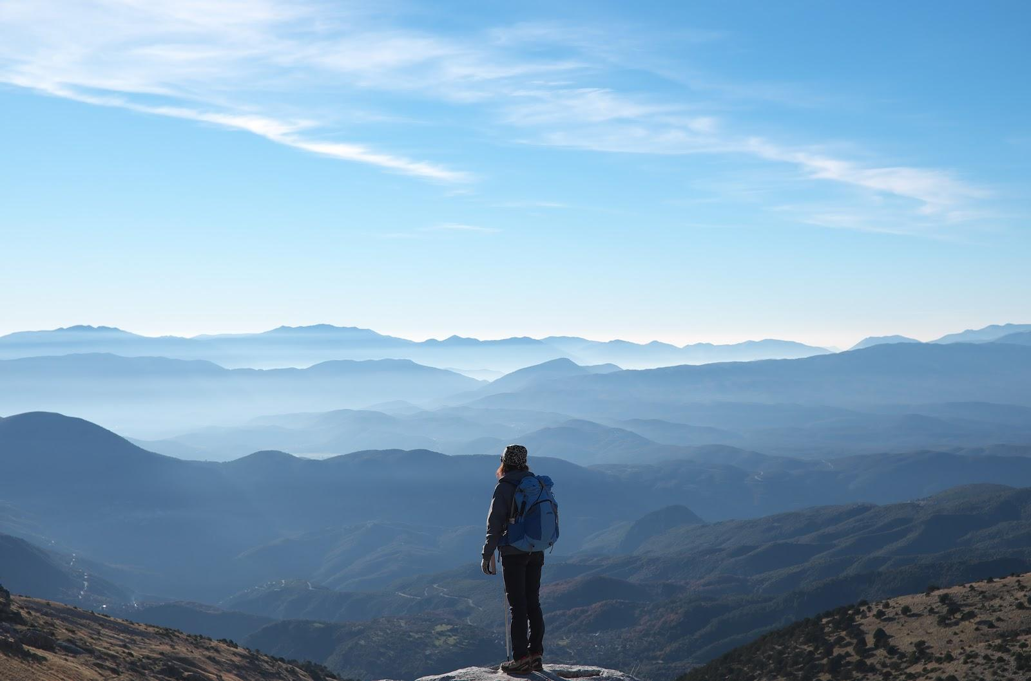

YOUR DESTINY AWAITS YOU...

WE ARE CALLING YOU DEAR SISTERS AND HEALERS TO JOIN US ON AN ADVENTURE OF A LIFETIME. JOIN OUR MISSION AND WALK TO RAISE THE VOICE AND VISIBILITY OF MARGINALIZED WOMEN THROUGH THE TRANSFORMATIONAL POWER OF PILGRIMAGE.

CASTING STARWALKERS AND HEALERS NOW FOR OUR FIRST PILGRIMAGE AND DOCUMENTARY SERIES

"A journey of a 1000 miles begins with a single step."-Lao Tzu

PROJECT SUMMARY

As it stands, women are in the midst of a profound rite of passage, and it is our time to rise and walk together to heal and envision a new future as one womanhood. With the current rise in awareness around gender equality issues with the #MeToo movement and the myriad of women's marches across continents, Star Walkers Foundation Inc. and Starwalkers documentary series is the call for action and initiation into a renewed sense of self and life’s purpose for women around the world.
This coming year’s documentary series will cover our first annual pilgrimage of a story of 13 women from different religious, racial, and ethnic backgrounds from around the globe. These women will come together by the transformational power of pilgrimage to empower themselves and inspire others through a 50-day, 500-mile (800-kilometer) trek on the ancient trail of the Camino de Santiago de Compostela (“The Way of the Stars”) from France to Spain.
This journey involves leaving behind friends, family, and work commitments to come together at a basic human level to be confronted with our strengths and weaknesses being stripped bare to discover the truth of who we really are and what it means to feel free, empowered, and independent. While walking and dissolving the old judgments and belief systems that have defined and limited us as women, we will unleash our authentic selves within the supporting web of healers that will join us weekly for healing sessions.
The Camino is an interfaith pilgrimage with its origins dating back to the Middle Ages, and it will be the road and catalyst to uniting our homecoming as women. The pilgrimage will begin in Lourdes, France to pay homage to the Black Madonna, or the archetypal Earth Mother as the eternal power of the feminine force. We will ask for her guidance, support, and protection over us on our journey and then continue Saint Jean Pied du Port to begin our walk to Santiago, Spain.
We are looking for a diverse group of healers to help us on the trail each week, and we are looking for a diverse group of women and stories for our documentary series including the following:
- A female soldier
- A Kung-Fu Nun, defying gender roles from the Himalayas
- A Saudi Arabian activist who fought for the right to drive or for any other women’s rights in the country
- A survivor of human trafficking
- A survivor of female genital mutilation
- An acid attack survivor
- An Arab/Persian female activist/resistor/blogger during the Arab Spring or Iranian Revolution
- A female from a traditionally male dominated profession such as CEO, tattoo artist, petroleum engineer
- A female political prisoner
- An American Indian woman
- A survivor of genocide from the Yazidis in Iraq
- A Rwandan or other African woman who has experienced war and/or genocide
- The first woman to be (senator/police chief/congresswoman/mayor/governor)
- A representative from the LGBTQ community
- An elderly woman who can tell the story of what it has been like to be a female through many generations
- A female endurance athlete
- A female in remission from breast cancer or healing from a hysterectomy
- A female with alopecia
- A mother from a large family
- A female who has traditional beliefs about a woman’s role
- A female Buddhist monk/preacher/rabbi/priestess
- A survivor of Honduras’ femicide
- A mother-daughter duo
- A pregnant woman

HOW TO APPLY

To apply please send an email to starwalkersproductions@gmail.com and tell us your name, where you are from, and why this project interests you. If you are selected, a Skype interview will be scheduled to further discuss the project.

BECOMING AN AMBASSADOR AND PART OF A LEGACY

By walking the Camino, you are becoming part of an amazing legacy of Starwalkers. Star Walkers is a foundation with next spring 2020 being its first annual walk of many to come. All Starwalker participants will become ambassadors after completing the pilgrimage. This means a Starwalker profile of you and your blog of your journey on the Camino will be accessible through our website and partner websites for others to view and prepare for their own journeys. We will also ask you to become the bridge that connects us with women centered organizations in your community to build a strong web of supporters for women empowerment initiatives.

You can view our website here. Also, if you cannot be a Starwalker, you can sponsor one today by donating to our campaign here. We need your support to make this vision a reality and appreciate you dearly.

In gratitude,

